E-Commerce Customer Behavior & Conversion Analysis
Project Overview
This project analyzes user behavior in an e-commerce platform to identify conversion bottlenecks, customer segments, and revenue opportunities. The analysis follows a structured workflow using Snowflake for data transformation and Power BI for visualization, simulating a real-world analytics pipeline.

Problem Statement
Despite high user traffic, conversion rates remain low and a large portion of users do not complete purchases. The goal of this project is to:
- Identify where users drop off in the funnel
- Understand customer behavior and segmentation
- Evaluate category and pricing performance
- Provide actionable recommendations to improve conversion and revenue

Dataset Overview
- Type: Event-level transactional data
- Volume: ~885,000 records
- Time Range: September 2020 – February 2021
- Grain: Each row represents a user interaction (view, cart, purchase)
Key fields include:
- event_time, event_type
- user_id, user_session
- product_id, category_code, brand
- price

Data Architecture
The project follows a structured analytics workflow:
Raw Event Data → Snowflake (SQL Transformation) → Analysis-Ready View → Power BI Dashboard
- Data cleaning and transformation were performed in Snowflake
- SQL CTE pipelines were used to standardize and prepare the data
- A reusable analysis-ready dataset was created for reporting
- Power BI was connected to the curated dataset for visualization
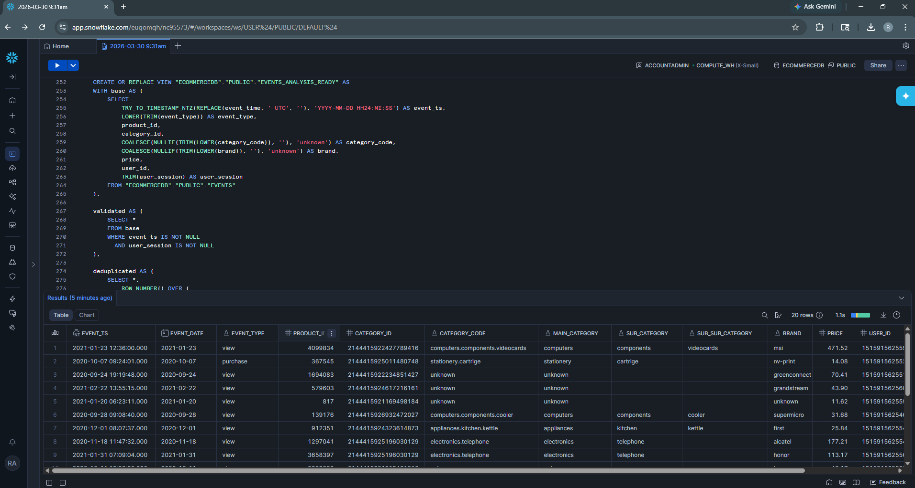

Data Preparation & Validation
Data quality checks were performed to ensure reliability:
- Converted timestamp from varchar to proper datetime format
- Removed duplicate records using window functions
- Identified missing values:
  - ~26.7% missing category
  - ~24% missing brand
- Standardized text fields and handled null values using “unknown” grouping
- Created derived features:
  - price buckets
  - category hierarchy
  - session-level metrics

Funnel Analysis
Funnel analysis reveals a significant drop-off at the early stage of the user journey.
- Views: 90%
- Carts: 6.11%
- Purchases: 4.22%
Conversion rates:
- View → Cart: 6.81%
- Cart → Purchase: 69.12%
This indicates that the primary bottleneck lies in converting browsing behavior into purchase intent. Once users reach the cart stage, they are highly likely to complete the purchase, suggesting that checkout friction is minimal.

Dashboard — Funnel Overview
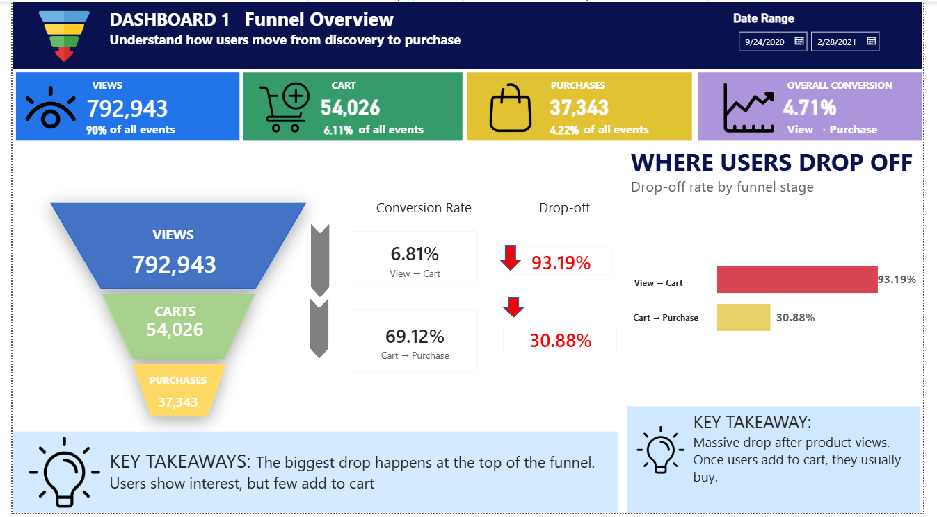
Customer Segmentation
User segmentation shows that the majority of users do not convert.
- Browsers: ~95% of users
- One-time buyers: major revenue contributor
- High-value customers: significant revenue share
- Repeat customers: consistent contribution
Revenue is concentrated among a small subset of users, while most users remain unconverted.

Dashboard — Customer Segmentation
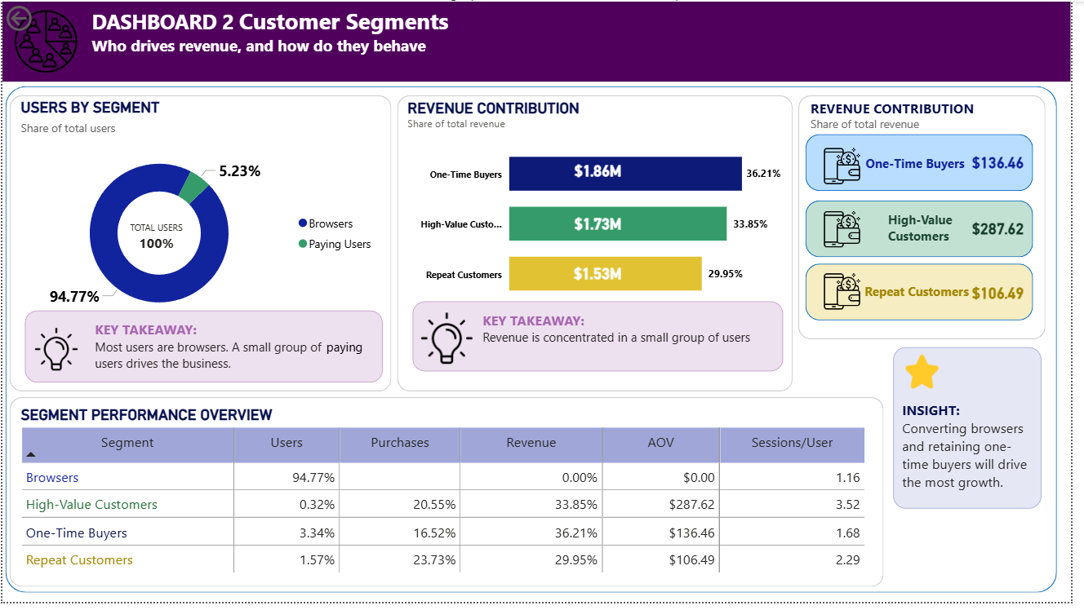
Category & Price Insights
Category performance varies significantly across the funnel:
Top-performing categories:
- Computers (high engagement)
- Stationery (strong conversion)
- Electronics (consistent performance)
Underperforming categories:
- Appliances (high traffic but low engagement)
- Apparel (low conversion)
Price behavior shows:
- Low-priced items have the highest conversion
- Mid-to-high tiers perform well overall
- Luxury products have the lowest conversion
These findings indicate that both product positioning and pricing play a critical role in conversion.
Dashboard — Category & Price Insights
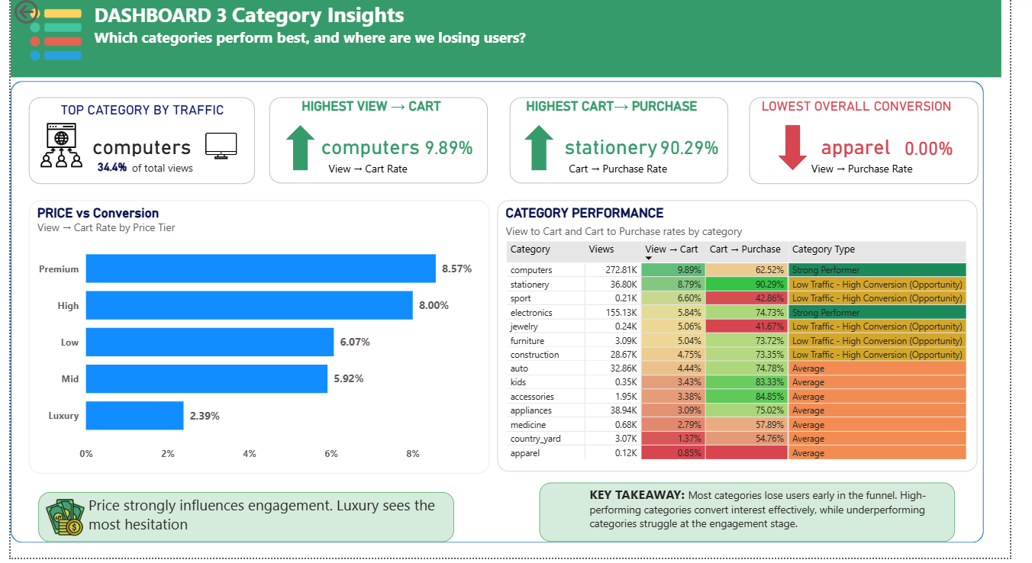

Behavioral Insights
Cart Abandonment
- Only ~8% of sessions reach cart
- ~50% of those users abandon
This highlights that a large portion of high-intent users are lost at the final stage of the funnel.

Session Behavior
Conversion increases significantly with engagement:
- Short sessions: 1.94%
- Medium sessions: 35.42%
- Long sessions: 47.40%
However, the majority of users fall into short sessions, indicating low engagement and low purchase intent.
This reveals two key user behaviors:
- Low-intent, quick browsing users (majority)
- Highly engaged, high-conversion users (minority)
The biggest opportunity lies in improving conversion among short-session users.
Dashboard — Behavioral Insights
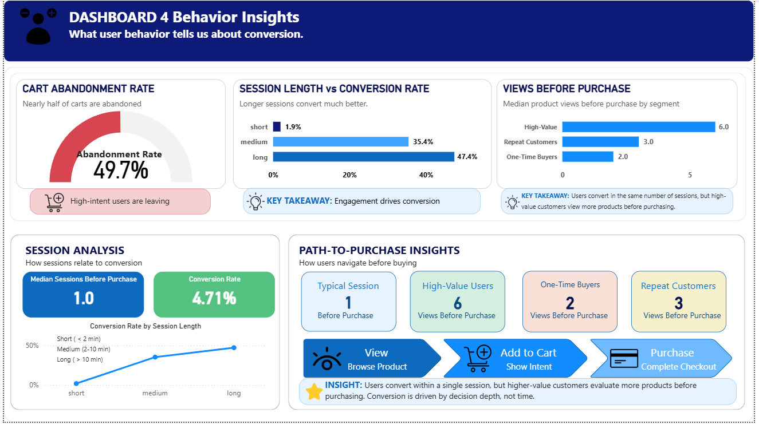

Key Business Insights
- The funnel is heavily top-heavy, with most users dropping off before adding to cart
- Checkout is efficient and not the primary issue
- Pricing and category performance significantly impact conversion
- The majority of users do not convert
- High-value users exhibit deeper engagement and product exploration
- Cart abandonment represents a high-impact opportunity

Recommendations
- Improve product engagement through better product pages, visuals, and reviews
- Enhance product discovery using recommendations and personalization
- Optimize pricing strategies through discounts, bundling, and financing
- Reduce decision friction with comparison tools and clearer product information
- Recover abandoned carts using retargeting strategies such as notifications
- Convert one-time buyers into repeat customers through targeted retention strategies
- Focus on scaling high-performing categories and improving underperforming ones

Technical Approach
- Built modular SQL pipelines in Snowflake using CTEs
- Performed data profiling, validation, and cleaning
- Created analysis-ready datasets using views
- Designed a structured data model for reporting
- Developed interactive dashboards in Power BI

Final Outcome
This project demonstrates the ability to:
- Work with large-scale event data in a cloud environment
- Build scalable data transformation pipelines
- Translate data into actionable business insights
- Design dashboards that support decision-making

